Piece | Issue | Answer
All | Can you confirm the English spellings of all the composers. The original list provided sometimes is different from what’s the spelling in the bio. Eg. Xie Xiangming combines the words.
1 | We seem to be missing the photo for this composer (and bio + synopsis we found but would be good to get your copy)
2 | Can we cut anything from the Bio, such as the Gramophone Review and birth year? It’s getting too long and extending to the next page [Fig. 1]
3 | Bio – the last line of the English bio ends with ‘etc.’ could we change it to ‘and more’ or something similar? [Fig. 2]
5 | Bio – Similar to Piece 2, it’s much longer. It’s fine to keep it this way and we could just remove the blank page at the end for cases where the bio is longer than a page. [Fig. 3]  Score – Can I confim the Xiao should be in this position, below the Suona?  [Fig. 4]
8 | Could we get the bio and photo, only has synopsis
SCO Works – Front Matter Errata

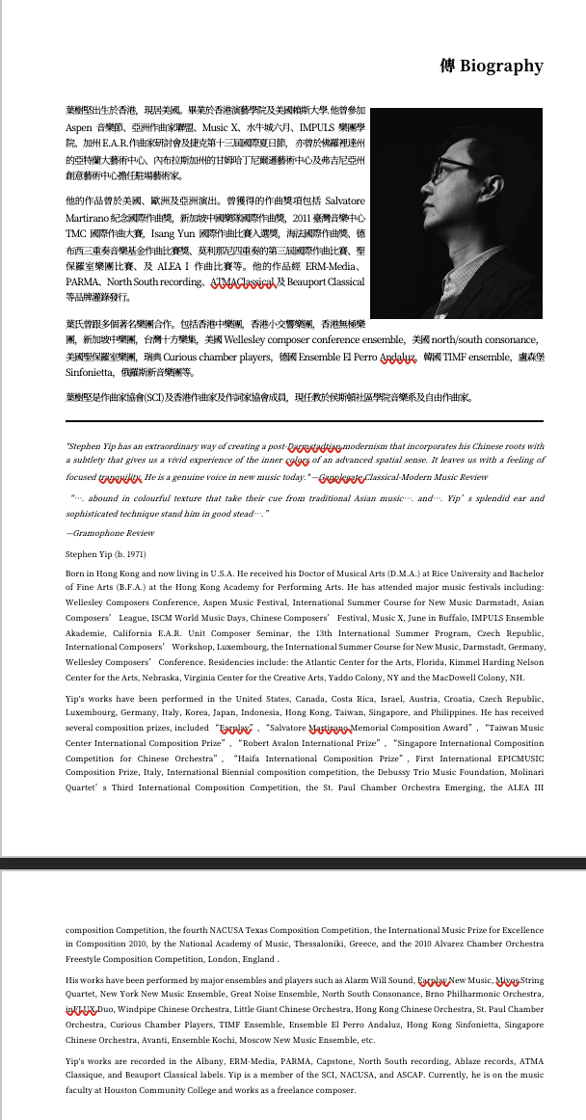
Figure 1: Piece 2 Bio too long

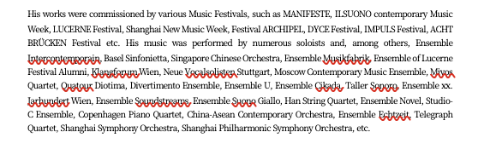
Figure 2: Piece 3 bio ends with 'etc.'
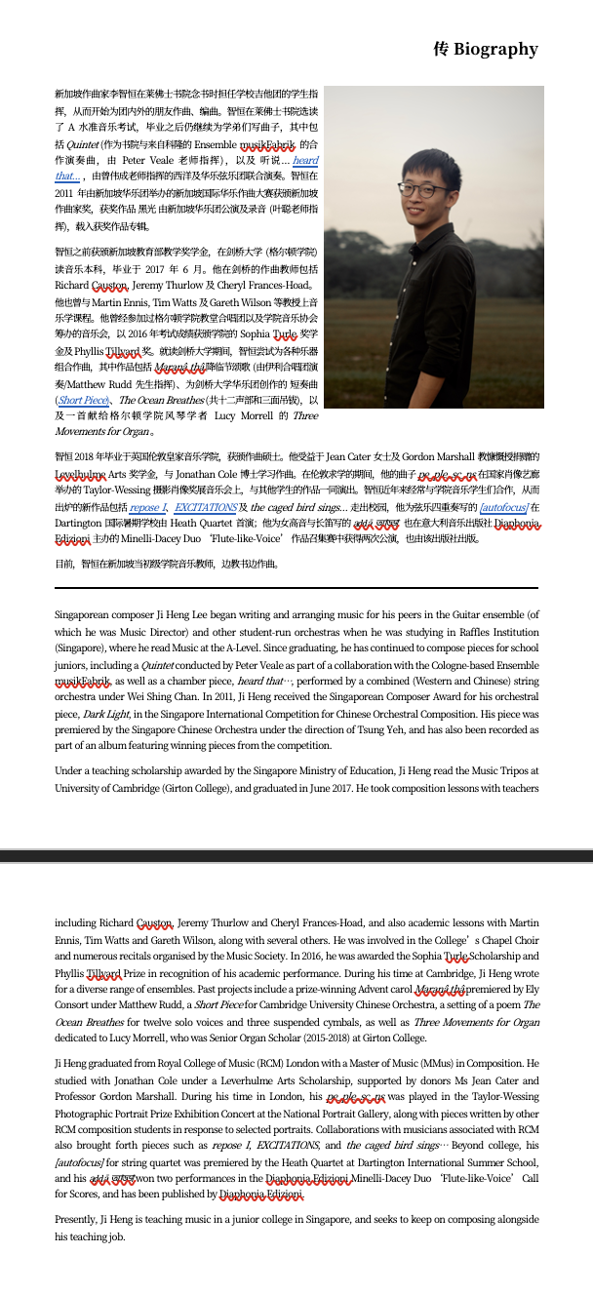
Figure 3: Piece 5 bio too long

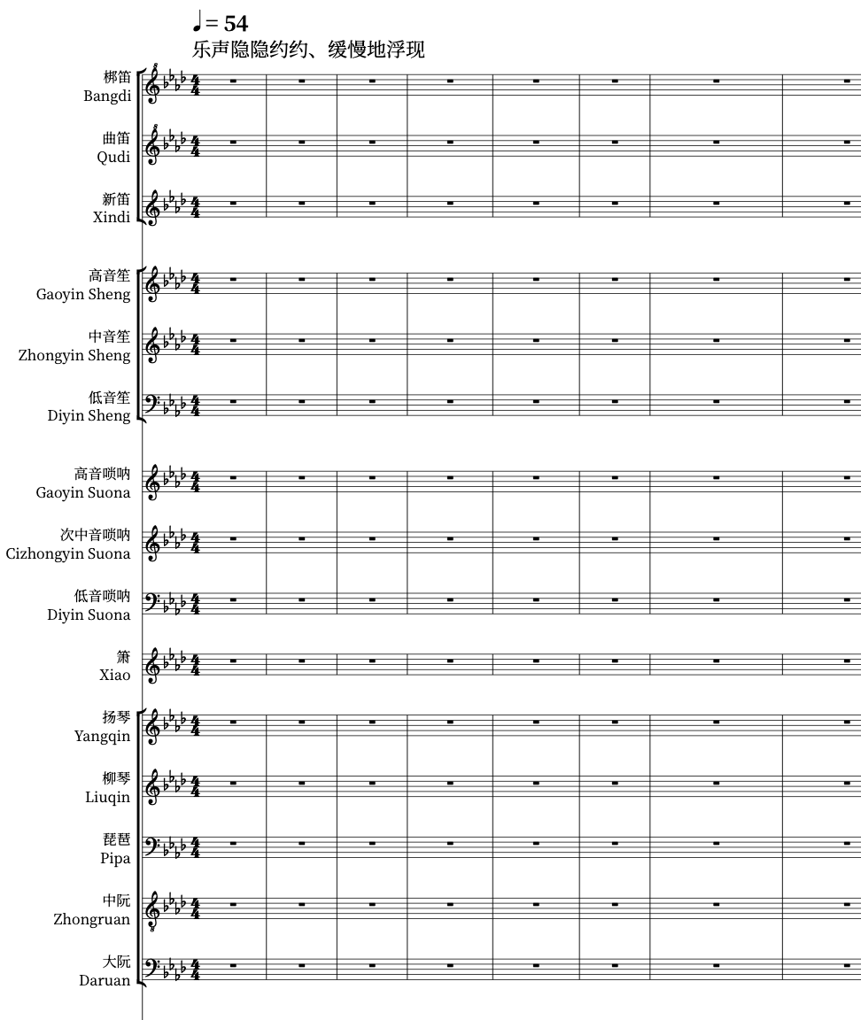
Figure 4: Position of Xiao for Piece 5

